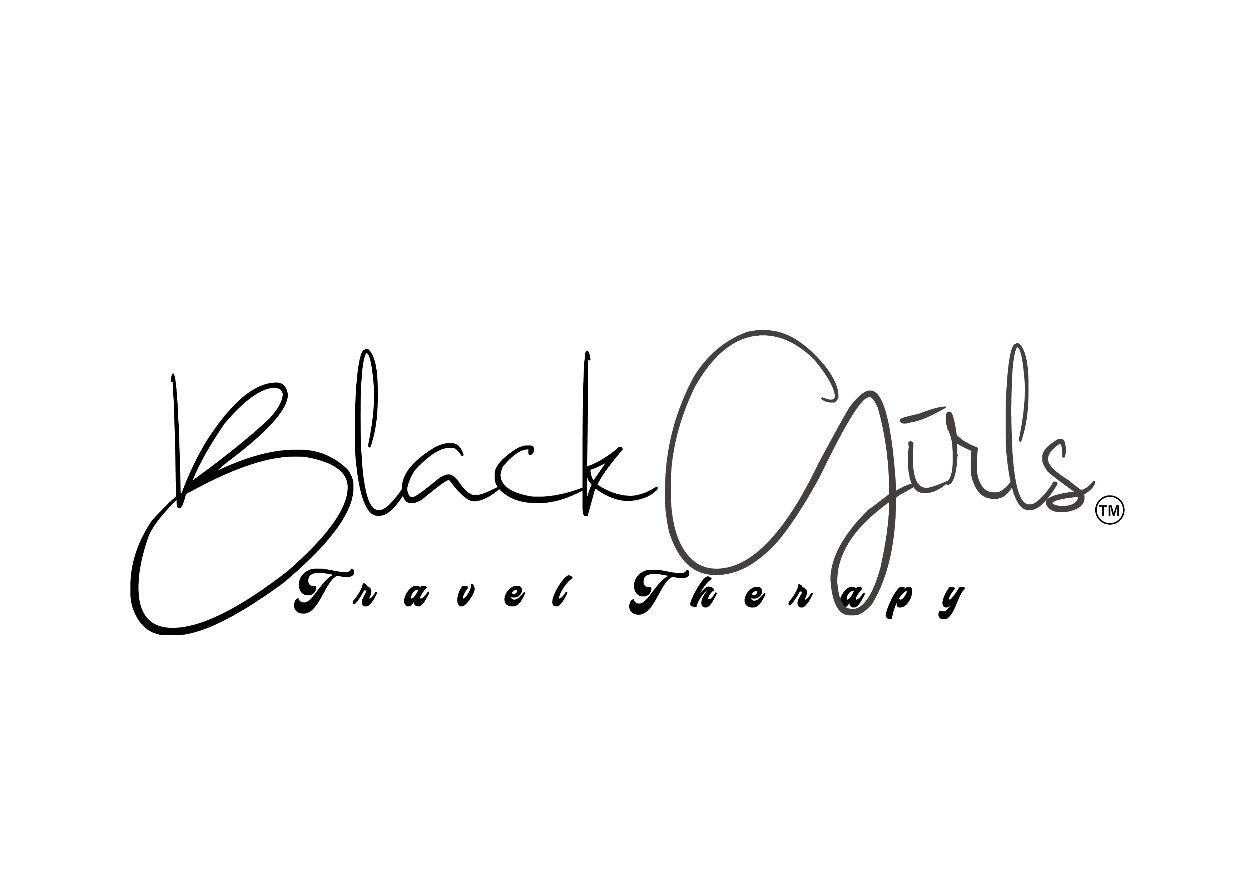
Hi, I wanted to introduce myself. My name is Karlyn and I own Black Girls Travel Therapy and the Dinner with Divas Program. We have chapters across the country and through our programming and membership benefits, we empower women to be their best selves.

As part of our Dinner with Divas Membership Program we provide our ladies with a discount business card that allows them to seek out businesses of interest in various areas and take advantage of discounts by those participating businesses.

We would love for you to sign up to participate as a Black Card member. It costs absolutely nothing to participate. You simply agree to offer a discount of your own choosing (minimum of 10% off) every time a Black Card is furnished to make a purchase at your place of business. We in turn, will include your business with a website link on our website under the "participating businesses directory". This is a great way to get new customers and clients through the door and to get your brand in front of a diverse group of women nationwide.

We look forward to promoting your business!

